# Assignment – 2

# for

**BLOCKCHAIN TECHNOLOGY**

**UEC635**

## Submitted By: Vishav Singla Roll number: 102115204 Group: 3NC8

**Submitted to**

# Dr. Shashikant

# Assistant Professor



**DEPARTMENT OF ELECTRONICS AND COMMUNICATION ENGINEERING**

**THAPAR INSTITUTE OF ENGINEERING AND TECHNOLOGY, (A DEEMED TO BE UNIVERSITY), PATIALA, PUNJAB**

**INDIA**

**January – May**

**2024**

**Deploy and run Smart Contracts on Metamask Account**

**Do the following:**

**1. Create your own metamask wallet visiting Metamask Link.**

**2. Setup your account and get some test ethers after connecting it to different test networks.**

**3. Write smart contracts in solidity visiting https://remix.ethereum.org/ and deploy it with your metamask account.**

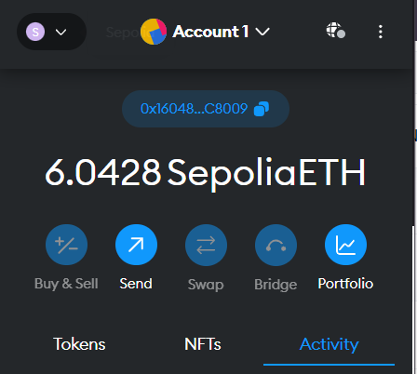

**Fig 2.1** Metamask Wallet created and Sepolia test ethers added

**CODE:**

// SPDX-License-Identifier: GPL-3.0

pragma solidity >=0.8.2 <0.9.0;

contract Storage {

    uint256 number;

    function store(uint256 num) public {

        number = num;

    }

    function retrieve() public view returns (uint256){

        return number;

    }

}

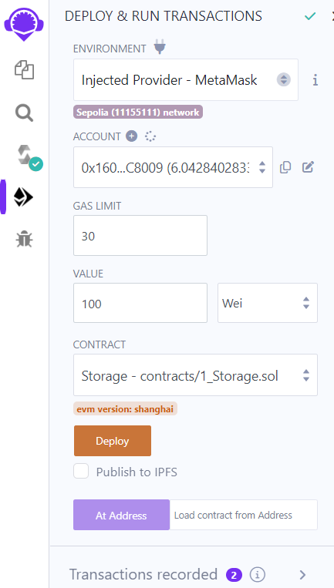

**Fig 2.2** Transaction requested from remix to Metamask

using injected Provider

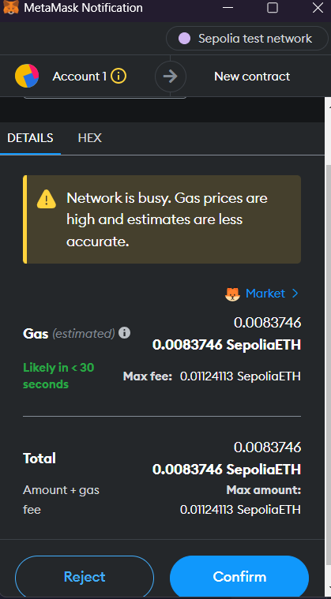

**Fig 2.3** Transaction request came from remix to Metamask

and we confirm the transaction

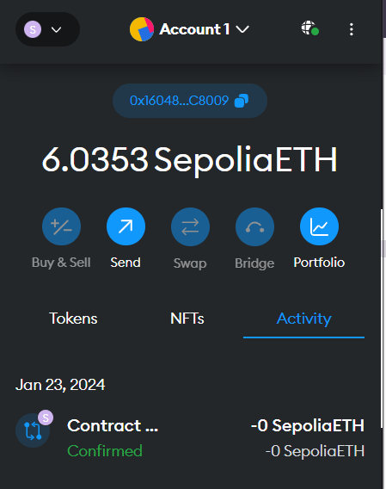

**Fig 2.4** transaction took place and gas fees is cut

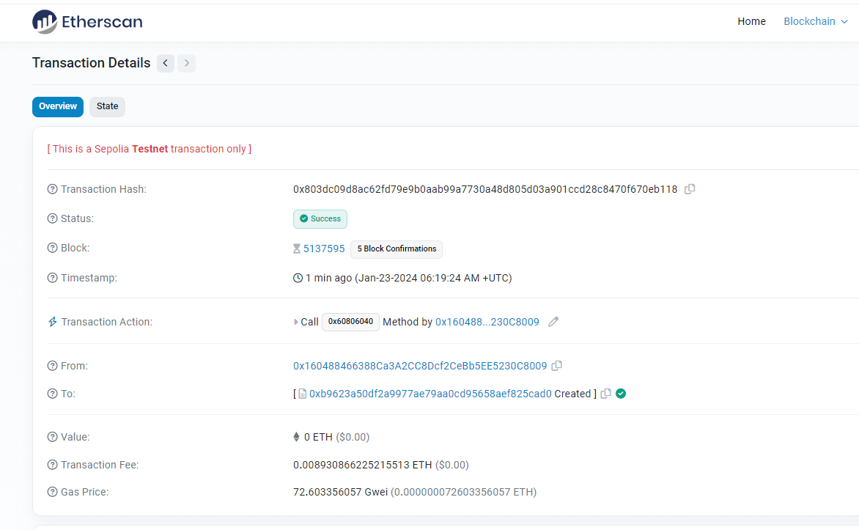

**Fig 2.5** transaction is listed on Etherscan sepolia testnet

<https://sepolia.etherscan.io/tx/0x803dc09d8ac62fd79e9b0aab99a7730a48d805d03a901ccd28c8470f670eb118>